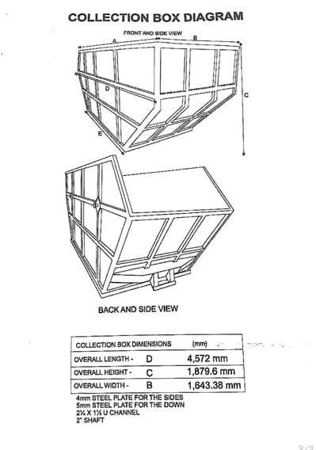
KPONE KATAMANSO MUNICIPAL ASSEMBLY
SPECIFICATION

PROJECT TITLE: SUPPLY OF 4-NO. COMMUNAL SKIP CONTAINERS FOR THE KPONE KATAMANSO MUNICIPAL ASSEMBLY
PACKAGE NUMBER: GAR/KKMA/DACF/GDS/RFQ/06/26

NO. | DESCRIPTION | REQUIRED | OFFER
1 | TYPE OF STEEL MATERIAL | GALVANIZED | GALVANIZED
2 | SIDE PLATE | 4 MM | 4 MM
3 | BASE PLATE | 5 MM | 5 MM
4 | SIDE HOOK | 14 MM | 14 MM
5 | 2.5 X 1.5 U-CHANNEL | 1^{1/2} X 2^{1/2} | 1^{1/2} X 2^{1/2}
6 | SHAFT | 18FT (2”)  50 MM ROUND BAR X 5.5M | 18FT (2”)  50 MM ROUND BAR X 5.5M
7 | COATING | ANTIRUST (RED OXIDE) | ANTIRUST (RED OXIDE)
8 | COLOUR | GREEN (SPRAYING) | GREEN (SPRAYING)

