

TENDER DOCUMENT

PROCUREMENT OF OFFICE FURNITURE

PRICE QUOTATION

IFT NO.: GR/NCCE/GDS/0001/2026

MAY, 2026

Table Contents

Table Contents i

Introduction and Instructions 1

Section I. Invitation for Sealed Quotation 2

Section II. Conditions of Contract 3

Section III. Form of Contract 7

Section IV. Sample Forms 9

Price Schedule for Goods Offered from Abroad 10

Price Schedule for Domestic Goods Offered from within Ghana …….11

Section V. Schedule of Requirements 12

Section VI. Technical Specifications 13

1

Introduction and Instructions

This Tender Document, Procurement of Goods – Price Quotation, has been prepared by the Public Procurement Authority for use by Procurement Entities in accordance with the Public Procurement Act, 2003 (Act 663) as amended of the Republic of Ghana when procuring goods which are estimated to cost not more than one hundred thousand Ghana cedis (GHS 100,000.00)¹.

This Standard Form has been developed based on relevant experience in this field.

- Or the equivalent threshold level as revised in accordance with the Public Procurement Act, 2003 (Act 663) as amended of the Republic of Ghana .

2
Section I. Invitation for Sealed Quotation

Name of Procurement Entity: NATIONAL COMMISSION FOR CIVIC EDUCATION

Address of Procurement Entity:

THE CHAIRMAN
NATIONAL COMMISSION FOR CIVIC EDUCATION
NCCE HEADQUARTERS – RIDGE, ACCRA

Tel: 0303-943-220 // 024-673-1012
Email: procurement@nccegh.org

Sealed Quotation No: GR/NCCE/GDS/0001/2026

Date of Invitation: 4TH MAY, 2026

  - The National Commission for Civic Education invites sealed quotations from eligible registered Suppliers for the supply of Office Furniture.

  - Procurement of Office Furniture
Schedule of Requirements
Lot | Item No. | Description of Goods | Quantity | Delivery Period
1 | 1 | Semi-Executive Desk (1600mm) | 3 | Twenty-Eight (28) days after receipt of the confirmed order
1 | 2 | Office Desk (1220mm) | 119 | Twenty-Eight (28) days after receipt of the confirmed order
2 | 1 | Semi-Executive Swivel Chair | 5 | Twenty-Eight (28) days after receipt of the confirmed order
2 | 2 | Block Chairs | 120 | Twenty-Eight (28) days after receipt of the confirmed order
Tenderers may quote for one or more lot
  - This invitation for quotations follows the general procurement notice for this project (price quotation), which was published in [insert publication] issue no [insert number] of [insert date] and in the Public Procurement Bulletin of the Public Procurement Authority of the Republic of Ghana, issue no. [Insert number] of [insert date].- Not Applicable

  - The Purchaser now invites sealed quotations from eligible Tenderers for the Procurement of Office Furniture.

  - Tendering will be conducted through the Price Quotation procedures specified in the Republic of Ghana’s Procurement Act, 2003, Act 663 as amended is open to all Tenderers from eligible source countries as defined in the Guidelines of the Public Procurement Authority of the Republic of Ghana.

  - Quotations must be delivered online via www.ghaneps.gov.gh at or before 2:00 p.m on 14th May, 2026.

  - Sealed quotations must be delivered online via www.ghaneps.gov.gh at or before 2:00 p.m on 14th May, 2026.

  - Sealed quotations will be opened electronically on www.ghaneps.gov.gh.

9. It is mandatory that Tenderers submit with their tender the following statutory
documents:

- Valid Business Registration Certificate
- Evidence of Renewal of Business Registration
- Valid VAT Registration Certificate.
- Valid Public Procurement Authority (PPA) Registration Certificate
- Valid SSNIT Clearance Certificate
- Valid GRA Tax Clearance Certificate

10. Criteria for the Tender Evaluation shall be on the basis of:
- Preliminary requirements in the provision of valid certificates
- Delivery requirement as per schedule of requirement
- Specific standard or criteria as per Technical Specification
- Sample inspection
- Past experience (Minimum Two (2) contracts)
- CIP Price

11. Tenders shall be valid for 90 days after submission.

Section II. Conditions of Contract

1. Definitions

1.1 In this contract, the following terms shall be interpreted as indicated:

a. "The Contract" means the agreement entered into between the Purchaser and the Supplier, as recorded in the Contract Form Signed by the parties, including all attachments and appendices thereto and all documents incorporated by reference therein;

b. "The Contract Price" means the price payable to the Supplier under the contract for the full and proper performance of its contractual obligation;

c. "The Goods" means Equipment and related Accessories and spare-parts which the Supplier is required to supply to the Purchaser under the contract;

d. "Services" means services ancillary to the supply of the goods such as transportation and insurance including the installation, commissioning and the operational and maintenance training of the supplied equipment.

e. "The Purchaser" means the organization purchasing the goods;

f. "The Supplier" means the organization supplying the goods and services under this contract.

2. Technical

Specification

2.1 The goods supplied under this contract shall conform to the standards mentioned in the Technical Specification.

3. Patent Right

3.1 The Supplier shall indemnify the Purchaser against all third-party claims of infringement of patent, trademark or industrial design rights arising from use of goods or any part thereof in the Purchaser's country.

4. Inspection and Tests

4. The Purchaser or its Representative shall have the right to inspect and/or test the goods to confirm their conformity to the Technical Specification and the quality of performance after the supply and delivery of good to Purchaser's premises.
The inspection shall involve the Purchasers team and Supplier Representative.

5. Packing

5.1 The Supplier shall provide such packing of the goods as is required to prevent their damage or deterioration during

5

transit to their final destination as indicated in the contract.

5.2 The packing shall be sufficient to withstand, without limitation, rough handling during transit and exposure to extreme temperatures, salt and precipitation during transit and open storage.

5.3 Packing case, size and weights shall take into consideration, where appropriate, the remoteness of the goods' final destination and the absence of heavy handling facilities at all points in transit.

5.4 The packing, marking and documentation within and outside the packages shall comply strictly with such special requirements as shall be expressly provided in accordance with international standard and practice.

6. Delivery of

Goods

6. Delivery of the goods shall be made by the Supplier in accordance with the terms specified by the Purchaser in its schedule of requirements.

6.2 For purposes of the contract "FOB", "C&F", "CIF", "CIP" and other trade terms used to describe the obligations of the parties shall have the meanings assigned to them by the current edition of the International Rules for the Interpretation of the Trade Terms (INCOTERMS) published by the International Chamber of Commerce (ICC), Paris.

7. Insurance

7.1 The goods supplied under the contract shall be fully insured in the currency of the tender price against loss or damage incidental to manufacture or acquisition, transportation, storage and delivery in the manner specified.

7.2 Where delivery of the goods is required by the Purchaser on a CIF or CIP basis to a specified destination, the Supplier shall arrange and pay for insurance, naming the Purchaser as the Beneficiary and the Supplier shall be required to meet all transport and storage expenses until delivery.

8. Warranty

88.1 The Supplier warrants that all the goods supplied under the contract shall fully comply with the specification laid down in the contract.

8.2 The warranty shall remain valid for one year after the goods have been delivered to the final destination indicated in the

6
contract, and accepted by the Purchaser after installation and
commissioning of equipment by the Supplier.

8.3 The Purchaser shall promptly notify the Supplier in writing
of any claims arising under this warranty.

8.4 Upon receipt of such notice, the Supplier shall, within 30
days replace the defective goods without cost to the
Purchaser. The Supplier will be required to remove, at its
own risk and cost, the defective goods.

9. Payment 9.1 Payment shall be made in the currency in which the contract
price has been stated in the Supplier's tender.

9.2 Payment of the goods supplied from within Ghana shall be
made in Ghanaian Cedis within a period Sixty (60) days after the delivery and installation
and commissioning of goods to the satisfaction of the
Purchaser.

9.3 Payment of the goods to be supplied from abroad shall be
made in the following manner:
Full payment on satisfactory delivery and acceptance of goods

9.4 Delay in payment of any amount due under sub-clause 9.3 shall
attract interest at […] calculated from the last date due for
Payment

10. Prices 10.1 Prices charged by the Supplier for goods delivered under the
contract shall not vary from the prices quoted by the Supplier
in its sealed quotation and not be subjected to Exchange Rate
Fluctuations.
7

- Liquidated Damages 11.1 If the Supplier fails to deliver any or all of the goods within the time period specified in the contract, the Purchaser shall, without prejudice to its other remedies under the contract,

deduct from the contract price, as liquidated damages, a sum equivalent to 1.0 percent of the contract price of delayed goods for each week of delay until actual delivery, up to a maximum deduction of 10 percent of the delayed goods' contract price. Once the maximum is reached, the Purchaser may consider termination of the contract.

12. Resolution of 12.1 The Purchaser and Supplier shall make every effort to resolve
Disputes amicably by direct informal negotiation any disagreement or
dispute arising between them under or in connection with the
contract.

12.2 If, after thirty (30) days from the commencement of such
informal negotiation, the Purchaser and Supplier have been
unable to resolve amicably a contract dispute, it shall be
referred by either party to an adjudicator agreed by the parties.
In the event of disagreement, the dispute shall be resolved
under the Alternative Dispute Resolution Act 2010 (Act
798)

13. Governing 13.1 The Governing Language shall be English
Language

14. Applicable 14.1 The applicable law shall be the Laws of Ghana.
Law

15. Notices 15.1 Purchaser's address for notice purposes:

15.2 Supplier’s address for notice purposes:

THE CHAIRMAN, NATIONAL COMMISSION FOR CIVIC

EDUCATION, HEADQUARTERS - RIDGE, ACCRA

16. Taxes and | 16.1 | The Supplier shall be entirely responsible for all taxes, duties,
Duties |  | licence fees and other such levies imposed by the
 |  | Government of Ghana.
17. Operation, | 17.1 | The successful Supplier shall supply 2 copies of
Maintenance and |  | manufacturer's operation, maintenance and spare-part
Spare-parts |  | manuals of the goods (Equipment).
Manuals

8
Section III. Form of Contract

THIS AGREEMENT made the day of 20 between [name of

Purchaser] (hereinafter called “the Purchaser”) of the one part and [name of Supplier] of [city and country of Supplier] (hereinafter called “the Supplier”) of the other part:

WHEREAS the Purchaser invited tenders for certain goods and ancillary services, viz.,

[brief description of goods and services]

and has accepted a tender by the Supplier for the supply of those goods and services in the sum of [contract price in words and figures] (hereinafter called “the Contract Price”).

NOW THIS AGREEMENT WITNESSETH AS FOLLOWS:

  - In this Agreement words and expressions shall have the same meanings as are respectively assigned to them in the Conditions of Contract referred to.

  - The following documents shall be deemed to form and be read and construed as part of this Agreement, viz.:

        - Tender Form and the Price Schedule submitted by the Supplier;

        - The Schedule of Requirements;

        - The Technical Specifications;

        - The Conditions of Contract; and

        - The Purchaser’s Notification of Award.

  - In consideration of the payments to be made by the Purchaser to the Supplier as hereinafter mentioned, the Supplier hereby covenants with the Purchaser to provide the goods and services and to remedy defects therein in conformity in all respects with the provisions of the Contract.

  - The Purchaser hereby covenants to pay the Supplier in consideration of the provision of the goods and services and the remedying of defects therein, the Contract Price or such other sum as may become payable under the provisions of the contract at the times and

in the manner prescribed by the Contract.

- This Agreement shall not be valid unless;

      - signing by both parties;

    - authorization in the form of a Purchase Order (PO) generated from the Ghana Integrated Financial Management Information Systems (GIFMIS) or in a form specified by the Ministry of Finance (MoF) pursuant to the Applicable Law;

- the fulfilment of conditions precedent such as the submission of performance bond, if any, that may be required on the part of either party under the Agreement or under the Applicable law.

9

IN WITNESS whereof the parties hereto have caused this Agreement to be executed in accordance with their respective laws the day and year first above written.

On behalf of the Purchaser On behalf of the Supplier

Name: Name:

Designation: Designation:

Sign: Sign:

Seal: Seal:

10

Section IV. Sample Forms

1. Tender and Price Schedules

Date:

To: [name and address of Purchaser]

Gentlemen and/or Ladies:

Having examined the RFQ documents, we the undersigned, offer to supply and deliver

[description of goods and services]

in conformity with the said RFQ documents for the sum of ,

[total tender amount in words and figures] or such other sums as may be ascertained in accordance with the Schedule of Prices attached herewith and made part of this Tender.

We undertake, if our Tender is accepted, to deliver the goods in accordance with the delivery schedule specified in the Schedule of Requirements.

If our Tender is accepted, we will obtain the guarantee of a bank in a sum equivalent to percent of the Contract Price for the due performance of the Contract, in the form

prescribed by the Purchaser.

We agree to abide by this Tender for a Period of [90] days from the date

fixed for Tender opening it shall remain binding upon us and may be accepted at any time before the expiration of that period.

Until a formal Contract is prepared and executed, this Tender, together with your written acceptance thereof and your notification of award, shall constitute a binding Contract between us.

We understand that you are not bound to accept the lowest or any tender you may receive.

Dated this |  |  | day of |  | 20 |  |  | .
[signature] |  |  |  |  | [in the capacity of]
Duly authorized to sign Tender for and on behalf of

11

Total CIP (place of destination) Price ………………………………… (in words)

Signature of Tenderer

Note: In case of discrepancy between unit price and total, the unit price shall prevail.

12
Price Schedule for Goods Offered from within

Ghana

Name of Supplier

No | Description | Country of  Origin | Quantity | Unit Price EXW  (Specify place) | Total Price  EXW | Total Price  of Inland  delivery to  final  destination | Total  CIP site  Plus VAT/NHIL | Incidental  Services  and others | Total  Tender  Price
1 | 2 | 3 | 4 | In figure  5 | 6=(4x5) | 7 | 8=(6+7) | 9 | 10=(8+9)
Grand
Total

Total CIP (place of destination) Tender Price …………………………………(in words)

Signature of Tenderer

Note: In case of discrepancy between unit price and total, the unit price shall prevail.

13

Section V. Schedule of Requirements

The delivery schedule expressed as weeks/months stipulates hereafter a delivery date which is the date of delivery when the contract is placed on CIP terms.

Lot | Item No. | Description of Goods | Quantity | Delivery Period
1 | 1 | Semi-Executive Desk (1600mm) | 3 | Twenty-Eight (28) days after receipt of the confirmed order
1 | 2 | Office Desk (1220mm) | 119 | Twenty-Eight (28) days after receipt of the confirmed order
2 | 1 | Semi-Executive Swivel Chair | 5 | Twenty-Eight (28) days after receipt of the confirmed order
2 | 2 | Block Chairs | 120 | Twenty-Eight (28) days after receipt of the confirmed order

14

Section VI. Technical Specifications
Lot 1: Semi-Executive Desk and Office Desk

Lot | Item No. | Description of Goods | Minimum Specifications | Offered Specifications
1 | 1 | Semi-Executive Desk (1600mm) | - Mahogany Veneer Desk  - Dimension for Desk:  - Width: 1600mm  - Depth : 800mm  - Height :762mm  - Cable management cutout  - Movable and lockable Drawer  - Side cabinet
1 | 2 | Office Desk (1220mm) | - Dimension for Desk:  - Width: 1220mm  - Depth : 635mm  - Height : 762mm  - Back Cover : 431.8mm  - 2 movable and lockable drawers  - Dimension for Movable and lockable Drawer:  - 2 Drawer  - Depth : 457.2mm  - Width : 406.4mm  - Height without wheels : 469.9mm  - Height with wheels :533.4mm  - Material: Engineered Wood (Melamine Board)  - Finish: Melamine Finish. The edges of top and legs shall be binded with additional melamine board.  - Cable management cutout
 |  |  | The Semi-Executive Desk and Office Desk shall be delivered at the head office and all the Sixteen (16) regional offices of the NCCE.
 |  |  | Warranty Period of One Year

- Tenderers shall submit a sample of the Office Desk to the NCCE Head Office after close of tender for evaluation.

- Samples of the Engineered wood (Melamine Board) can be inspected at the Office of the Procurement Unit, NCCE Head Office, Ridge-Accra.

Lot 2: Semi-Executive Swivel Chair and Block Chair

Lot | Item No. | Description of Goods | Minimum Specifications | Offered Specifications
2 | 1 | Semi-Executive Swivel Chair | - Overall Adjustable Heigth:  - Minimum: 49 Inches  - Maximum: 53 Inches  - Overall Width (ie from Left armrest to Right arm rest) : 23 Inches
  - High back Semi Executive Leather Swivel Chair with padded armrest.
  - Chair to come in high quality leather.
  - Chair to stand on a five-star chrome base with five number twin wheel swivel castors and a durable height, tilt adjustment and Gas Lift mechanism.
2 | 2 | Block Chair | - High back block chair with arm rests.  - Chair to come in high quality leather.  - Arm rests with wood/rubber covering.  - Heavy chrome frame with special floor glides which protect against tipping.  - Dimensions:  - Back Height : 24 inches  - Seat Height : 18 inches  - Seat Depth : 20.5 inches  - Overall Height : Between 39 to 42 inches  - Seat Width :19 inches  - Overall Width :22 inches
 |  |  | The Block Chairs shall be delivered at the head office and all the Sixteen (16) regional offices of the NCCE.
 |  |  | Warranty Period of One Year

Tenderers shall submit samples of the Semi-Executive Swivel Chair and the Block Chairs to the NCCE Head Office at the close of tender for evaluation.

Tentative Photograph of the Office Furniture

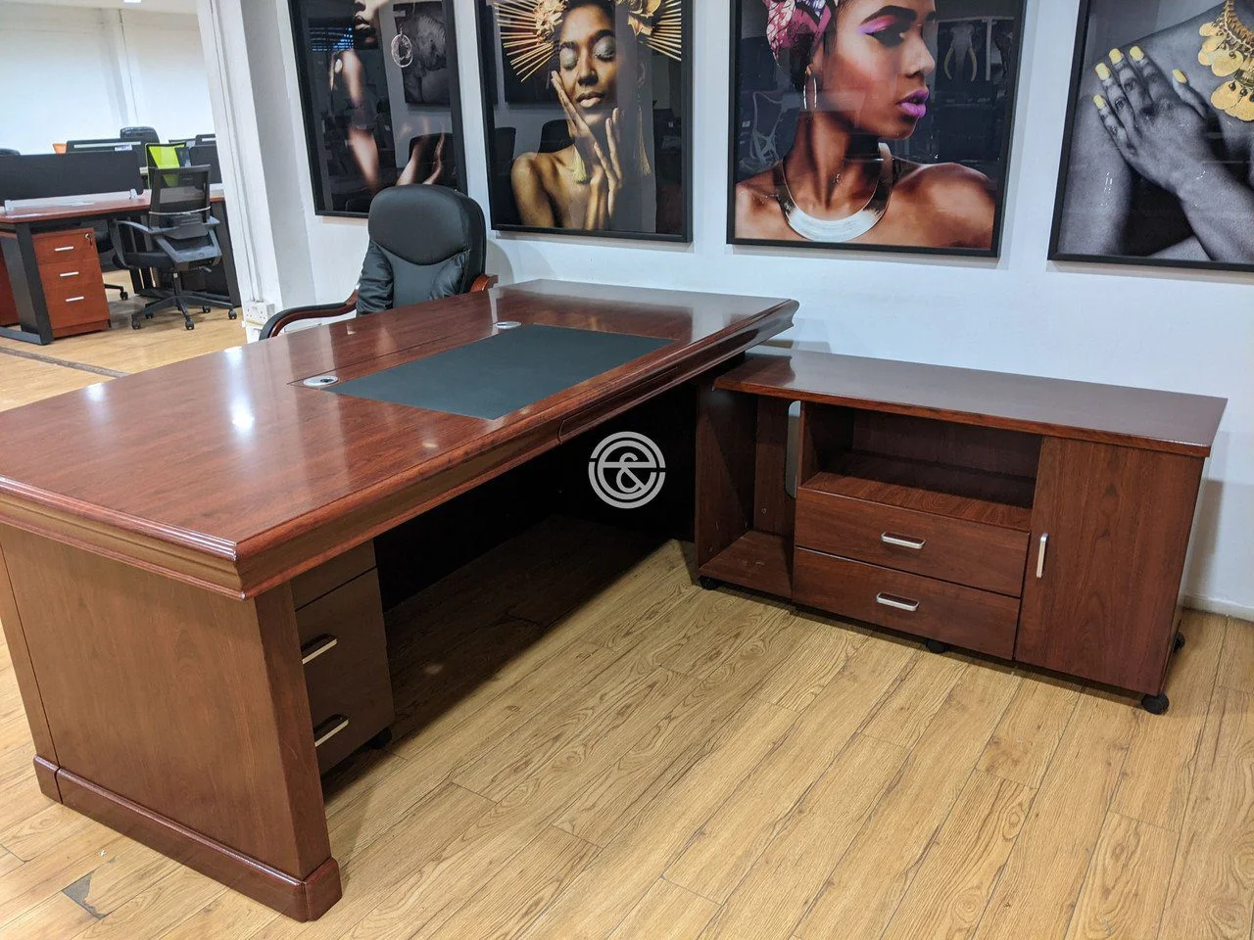

Semi-Executive Office Desk

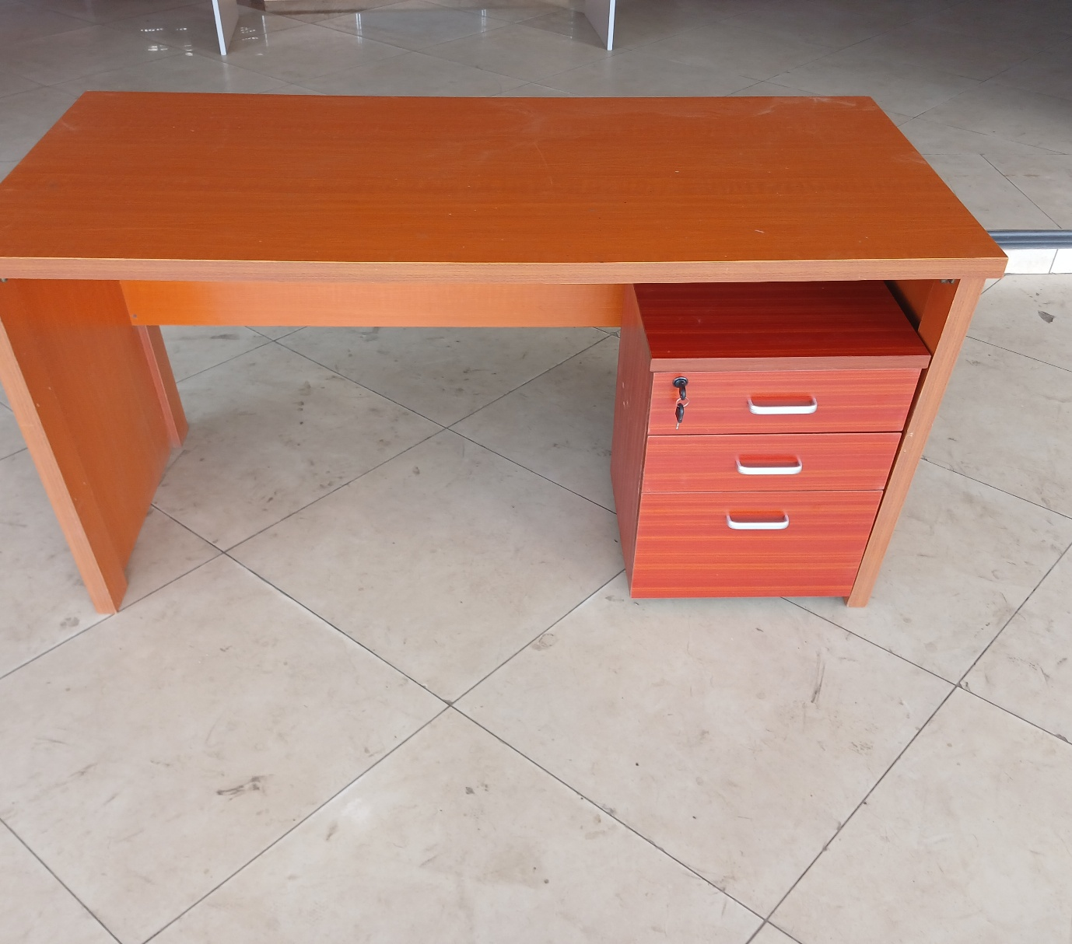

Office Desk



Semi-Executive Swivel Chair



Block Chair

Samples of the Engineered wood (Melamine Board)
