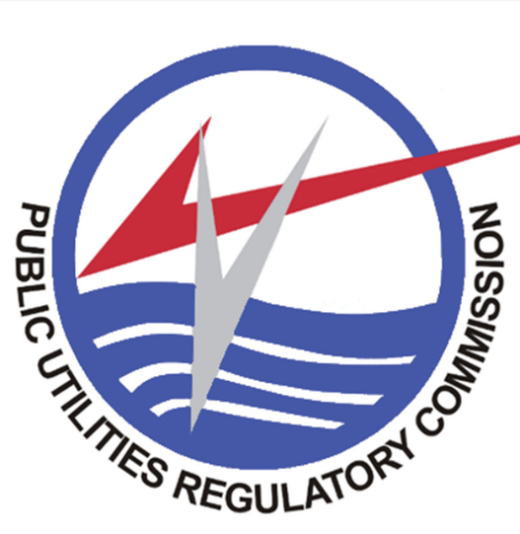
REQUEST FOR QUOTATION FOR THE SUPPLY AND DELIVERY OF OFFICE SUPPLIES-DETERGENTS

IFT NO: GR/PURC/GD/33/25

REQUEST FOR QUOTATION DOCUMENT

Date: Thursday November 27, 2025
The Public Utilities Regulatory Commission (PURC) invites sealed quotations from eligible and registered suppliers for the Supply and Delivery of Detergents
Tendering will be conducted through the Request for Quotation Procurement Method in accordance with the Public Procurement Act, 2003 (Act 663) as amended.

1. Mandatory Submission Requirements
Suppliers must submit:
- Valid Business Registration Certificate
- Valid VAT Registration Certificate
- Valid PPA Registration Certificate
Failure to submit any shall lead to disqualification.

2. Schedule of Requirements (Technical Specifications)
No. | Description | Quantity
1 | Dish Wash Soap (Sunlight) | 6 BOX
2 | Harpic Block | 12 PCS
3 | Hand Tissue (Washroom) | 12 PKS
4 | Hand Wash Soap (Washroom) | 96 PCS
5 | Glade | 6 PKS
6 | Washing Powder | 1 BAG
7 | Disposable Cups | 10 BOX
8 | Parazone | 12 PCS
9 | Mr. Muscle | 6 PCS

3. Delivery
Delivery shall be completed within 14 days after Contract Award to PURC Head Office, Accra

4. Evaluation Criteria
Evaluation will be based on:
- Preliminary Evaluation
- Technical Evaluation
- Commercial Evaluation
- Lowest evaluated responsive price
The contract will be awarded to the lowest evaluated responsive supplier.

5. Validity
Quotations shall remain valid for 60 days

6. Payment Terms
Payment shall be made within 30 days upon submission of VAT invoice and delivery documents

7. Submission
Tenders must be submitted electronically via GHANEPS (www.ghaneps.gov.gh)
Deadline: 1:00pm, Tuesday, December 9, 2025
Opening: 1:30pm, same day via GHANEPS
SIGNED:
Management
Public Utilities Regulatory Commission

